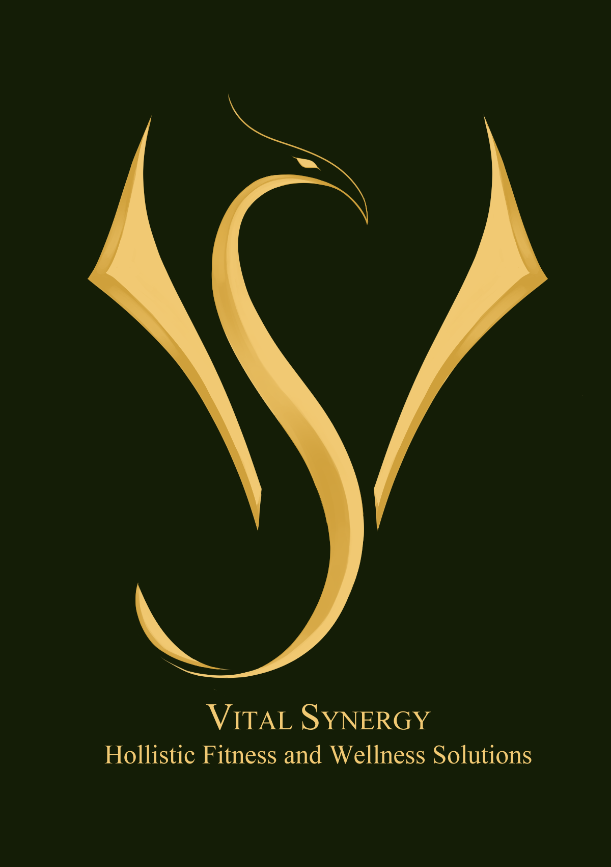 | VITAL SYNERGY  HOLISTIC FITNESS & WELLNESS SOLUTIONS  admin@vitalsynergy.net

ADDITIONAL INFORMATION ON SELF-TRAINING PROGRAMS

Thank you for your inquiry. Commencing with a Training program will set you on the journey to a New You. By having a firm plan in place when you enter the workout room you will avoid the guess work, be more time efficient and effective in your workouts. Without regard to how many times per week you are training it is important to know that it is contributing to your overall health.

This offer is for ladies who have a training history and are experienced using gym equipment and various training modalities and can manage to train by themselves, but lack the time and the structure. Programs are based on the results of the assessment. Assessment is conducted prior to tailoring of the program and is available on-site or via Facetime. Assessment is a thorough compulsory procedure which requires some time to be completed and is not included in the Personal Training fee. There are 2 types of Assessments:

A1- The entire screening process is conducted by Personal trainer on-site. (Investment: £45)
A2 – Client takes own body stats and weight. (Investment: £40)

ONCE PER WEEK SELF-TRAINING PROGRAMS

EXPRESS A1- PROGRAM for Self-Training
(Assessment 1:1 + Tailor-made 5 Weeks ONCE per WEEK Self-Training Programe)
@ £105 (*)

The Once per Week Program is designed for busy women who can manage to exercise only once in a week.

Assessment (*) – A1: (complete assessment including weight and body circumferences on the day of 1:1 assessment).
ARRIVE IN THIGHT AND FORM FITTING GEAR to facilitate correct assessment.

Assessment involves:
- Blood pressure check (1:1 only)
- Weighing
- Taking Body Measurements
- WHR (calculating your Waist:Hip Ratio)
- BMI (calculating your Body Mass Index)
- Static postural assessment
- Dynamic postural assessment (you will be performing some exercises)
- Strength assessment (you will be performing some exercises)
- Flexibility assessment
- Balance assessment
- Coordination assessment
- Assessment Report

After the assessment you will receive Once per Week Training Program which you will be following for 5 weeks, with each week listing the progressive change in training variables.

After 5 weeks you can opt for another reassessment, and opt for a new program which will be created for you based on your achievement.

PROGRESS CONSULTATION AT ANY POINT OF YOUR SELF-TRAINING (via WhatsUp/Facetime)
@ £20 / 20 min
@ £30 / 30 min

EXPRESS A2 - PROGRAM for Self-Training
(Assessment excluding weighing & body measurements +
Tailor-made 5 Weeks ONCE per WEEK Self-Training Program Only)
@ £100 (**)

The Once per Week Program is designed for busy women who can manage to exercise only once in a week.

Assessment (**) – A2: (excluding weight and body circumferences – client weighs and measures oneself in case of Face-time assessment or if chooses to provide the results and bring data in on the day of 1:1 assessment).

Please conduct the weighing in the morning after voiding your bowel and measure following body circumferences:
- Chest (across nipple line)
- Chest (under the breasts)
- Waist (at the narrowest point)
- Hips (at the widest point)
- Biceps (at mid upper arm, relaxed, both arms)
- Biceps (at mid upper arm, flexed, both arms)
- Thighs (at widest point, both legs)

After the assessment you will receive Once per Week Training Program which you will be following for 5 weeks, with each week listing the progressive change in training variables.

After 5 weeks you can opt for another reassessment, and another new program which will be created for you based on your achievement.

PROGRESS CONSULTATION AT ANY POINT OF YOUR SELF-TRAINING (via Facetime)
@ £20 / 20 min
@ £30 / 30 min

TWICE PER WEEK 5 WEEKS PROGRAMS
INTERMEDIATE A1 - PROGRAM for Self-Training
(Assessment 1:1 + Tailor-made 5 Weeks TWICE per WEEK Self-Training Programe Only)
@ £160 (*)
(*)A1 – entire assessment done on-site.

Please read the information about Assessment in Once Per Week programs above. (*) and the Additional Assessments Information.

After the assessment you will receive Once per Week Training Program which you will be following for 5 weeks, with each week listing the progressive change in training variables.

After 5 weeks you can opt for another reassessment and opt for a new program which will be created for you based on your achievement.

PROGRESS CONSULTATION AT ANY POINT OF YOUR SELF-TRAINING (via WhatsUp/Facetime)
@ £20 / 20 min
@ £30 / 30 min

INTERMEDIATE A2 - PROGRAM for Self-Training
(Assessment excluding weighing & body measurements + Tailor-made 5 Weeks TWICE per WEEK Self-Training Program Only)
@ £155 (**)
(**) A2 - weighing & body measurements done by client at home.

Please read information about Assessment in Once Per Week programs above and the Additional Assessment information. (**).

PROGRESS CONSULTATION AT ANY POINT OF YOUR SELF-TRAINING (via WhatsUp/Facetime)
@ £20 / 20 min
@ £30 / 30 min

TRICE PER WEEK TRAINING PROGRAMS

ADVANCED A1 - PROGRAM for Self-Training
(Assessment excluding weighing & body measurements + Tailor-made 5 Weeks TRICE per WEEK Self-Training Program Only)
@ £220 (*)
(*) A1 – entire assessment done on-site.

ADVANCED A2 - PROGRAM for Self-Training
(Assessment excluding weighing & body measurements + Tailor-made 5 Weeks TRICE per WEEK Self-Training Program Only)
@ £215 (**)
(**) A2 - weighing & body measurements done by client at home.

ADDITONAL ASSESSMENT INFORMATION

Physical assessment helps with devising the most suitable and beneficial fitness plan for your attainable fitness goals. This screening process gives an accurate picture of your current fitness level and indication of appropriate starting training intensities and a baseline for your fitness goals. Assessment is not included in the personal training investment. Please note the investment for Assessment options A1 and A2 in the above information.

What do I do prior to the assessment?

1/ Fill in and email back the following paperwork:
- PARQ form (*)
(*) – if you answer YES to any questions in PARQ form (except alternative medicine section), you will need to bring in doctor’s release letter allowing you participation in physical activities.
- If you are receiving any alternative medicine/healing treatments, please state which ones, frequency, and duration of such treatments (listed in the yellow section of PARQ form). You do not need therapist’s release letter if you are receiving specific alternative medicine treatment/s. Kindly note that the Assessment will not be conducted if you do not provide all necessary paperwork prior to commencement of the Assessment.
- Disclaimer;
- Fitness Questionnaire (your fitness history, training preferences etc);
- Read guidelines and Q and A. Contact for more information if needed.
2/ To ensure the best experience and correct assessment results, please abstain from drinking alcohol at least 24 hours prior; caffeine at least 6 hours; smoking, heavy meal intake at least 90 minutes before arriving for the testing.

3/ To avoid damage and hindering the assessment do not bring or remove jewelry.

4/ Tie long hair.

What is involved in a physical assessment?

The assessment involves static (e.g. body statistics, blood pressure taking) and dynamic screening (sets of simple exercises) evaluating your strength, posture, flexibility, balance, and coordination.

What do I need to bring for the assessment?

A comfortable, form fitting training outfit to facilitate postural screening and better insight into the body form during the assessment. Loose clothing might obscure body portions that are observed and contribute to a wrong assessment conclusion (e.g. overly wide t-shirts covering lumbar region, loose pants obscuring the knees position. During specific tests you will be working barefoot but for training, flat soled training shoes are recommended. No platformed or thick soled and outdoor shoes please.

I WILL BE HAPPY TO DISCUSS WITH YOU ANY OTHER FORM OF SELF-TRAINING OR 1:1 TRAINING PROGRAM.

I am looking forward to embarking on this journey of transformation with you. If you have any questions further questions regarding the program, please do not hesitate to contact me.

Wishing you an exciting and rewarding fitness journey!

Warmest regards,

Zorica (Zoe) King

